CODE THAT USE IN E-COMMERCE SQL PROJECT

- SELECT * FROM [e-commerce_data]

- USE [E-commerce Database];
SELECT COUNT(*) AS total_rows
FROM [e-commerce_data];

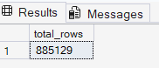

- USE [E-commerce Database];
SELECT event_type, COUNT(*) AS total_count
FROM [e-commerce_data]
GROUP BY event_type;
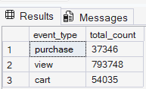

--Data Cleaning and Validation
-- NULL Brands

- USE [E-commerce Database];
SELECT COUNT(*) AS null_brand
FROM [e-commerce_data]
WHERE brand IS NULL;
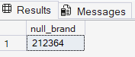

- --NULL Category
USE [E-commerce Database];
SELECT COUNT(*) AS null_category
FROM [e-commerce_data]
WHERE category_code IS NULL;
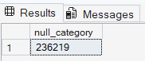

- --NULL Price
USE [E-commerce Database];
SELECT COUNT(*) AS null_price
FROM [e-commerce_data]
WHERE price IS NULL;

- --Price Range
USE [E-commerce Database];
SELECT
ROUND(MIN(price),2) AS min_price,
ROUND(MAX(price),2) AS max_price,
ROUND(AVG(price),2) AS avg_price
FROM [e-commerce_data];
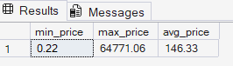

- --Duplicate Rows
USE [E-commerce Database];
WITH cte AS (
SELECT *,
ROW_NUMBER() OVER (
PARTITION BYevent_time,event_type,product_id,user_id,user_session
ORDER BY event_time
) rn
FROM [e-commerce_data]
)
SELECT COUNT(*) AS duplicate_rows
FROM cte
WHERE rn > 1;
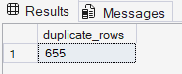

- --Replace null brand
USE [E-commerce Database];
UPDATE [e-commerce_data]
SET brand = 'Unknown'
WHERE brand IS NULL;

- --Replace null category
USE [E-commerce Database];
UPDATE [e-commerce_data]
SET category_code = 'Unknown'
WHERE category_code IS NULL;

- --Remove Duplicate rows
USE [E-commerce Database];
WITH cte AS (
SELECT *,
ROW_NUMBER() OVER (
PARTITION BY event_time,event_type,product_id,user_id,user_session
ORDER BY event_time
) rn
FROM [e-commerce_data]
)
DELETE FROM cte
WHERE rn > 1;

- --BUSINESS UNDERSTANDING

--Event Distribution
SELECT event_type, COUNT(*) AS total_events
FROM [e-commerce_data]
GROUP BY event_type
ORDER BY total_events DESC;
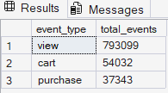

- --Percentage distribution
SELECT
event_type,
COUNT(*) AS total_events,
CAST(ROUND(100.0 * COUNT(*) / SUM(COUNT(*)) OVER(),2) AS decimal(10,2)) AS percentage_share
FROM [e-commerce_data]
GROUP BY event_type;
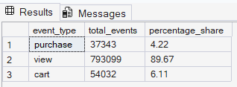
- --Final Insights
SELECT
SUM(CASE WHEN event_type = 'view' THEN 1 ELSE 0 END) AS views,
SUM(CASE WHEN event_type = 'cart' THEN 1 ELSE 0 END) AS carts,
SUM(CASE WHEN event_type = 'purchase' THEN 1 ELSE 0 END) AS purchases
FROM [e-commerce_data];
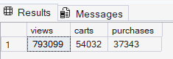

- --Total Revenue
SELECT ROUND(SUM(price),2) AS total_revenue
FROM [e-commerce_data]
WHERE event_type = 'purchase';
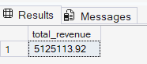

- --Total Purchases
SELECT COUNT(*) AS total_purchases
FROM [e-commerce_data]
WHERE event_type = 'purchase';
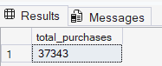

- --Average Order Value
SELECT ROUND(AVG(price),2) AS avg_order_value
FROM [e-commerce_data]
WHERE event_type = 'purchase';
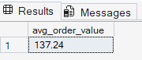

- --Revenue by Brand
SELECT TOP 10
brand,
ROUND(SUM(price),2) AS revenue
FROM [e-commerce_data]
WHERE event_type='purchase'
AND brand <> 'Unknown'
GROUP BY brand
ORDER BY revenue DESC;
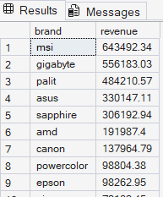

- --Revenue by Category
SELECT TOP 10
category_code,
ROUND(SUM(price),2) AS revenue
FROM [e-commerce_data]
WHERE event_type='purchase'
AND category_code <> 'Unknown'
GROUP BY category_code
ORDER BY revenue DESC;
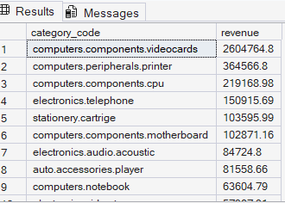

- --Funnel Breakdown
SELECT event_type, COUNT(*) AS users
FROM [e-commerce_data]
GROUP BY event_type;
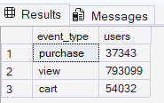
- --Conversion Rate (View → Purchase)
SELECT
CAST(100.0 * SUM(CASE WHEN event_type='purchase' THEN 1 ELSE 0 END) /
NULLIF(SUM(CASE WHEN event_type='view' THEN 1 ELSE 0 END),0)
AS decimal(10,2)) AS conversion_rate
FROM [e-commerce_data];
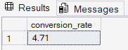

- --Cart Abandonment Insight
SELECT
CAST(100.0 * SUM(CASE WHEN event_type='cart' THEN 1 ELSE 0 END) /
NULLIF(SUM(CASE WHEN event_type='view' THEN 1 ELSE 0 END),0)
AS decimal (10,2)) AS view_to_cart_rate
FROM [e-commerce_data];
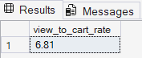

- --Drop-off Analysis
SELECT
SUM(CASE WHEN event_type='view' THEN 1 ELSE 0 END) AS views,
SUM(CASE WHEN event_type='cart' THEN 1 ELSE 0 END) AS carts,
SUM(CASE WHEN event_type='purchase' THEN 1 ELSE 0 END) AS purchases,
(
SUM(CASE WHEN event_type='view' THEN 1 ELSE 0 END)
- SUM(CASE WHEN event_type='purchase' THEN 1 ELSE 0 END)
) AS drop_off
FROM [e-commerce_data];
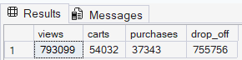

- --Top product by revenue
SELECT TOP 10
product_id,
ROUND(SUM(price),2) AS revenue
FROM [e-commerce_data]
WHERE event_type='purchase'
GROUP BY product_id
ORDER BY revenue DESC;
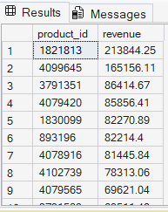

- --Brand Contribution %
SELECT
brand,
ROUND(SUM(price),2) AS revenue,
ROUND(100.0 * SUM(price) / SUM(SUM(price)) OVER(),2) AS revenue_share
FROM [e-commerce_data]
WHERE event_type='purchase'
AND brand <> 'Unknown'
GROUP BY brand;
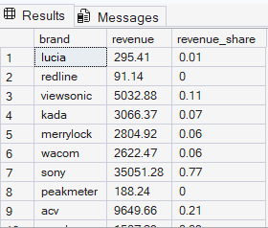

- --Average Price by Category
SELECT
category_code,
ROUND(AVG(price),2) AS avg_price
FROM [e-commerce_data]
WHERE event_type='purchase'
GROUP BY category_code
ORDER BY avg_price DESC;
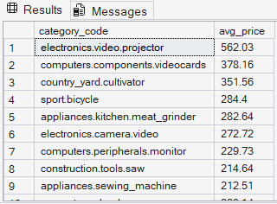

- --Active Users (Unique Users)
SELECT COUNT(DISTINCT user_id) AS total_users
FROM [e-commerce_data];

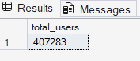

- --Session Activity
SELECT COUNT(DISTINCT user_session) AS total_sessions
FROM [e-commerce_data];
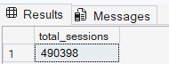

- --Avg Events per User (Engagement)
SELECT
CAST(ROUND(COUNT(*) * 1.0 / COUNT(DISTINCT user_id),2) AS decimal(10,2)) avg_events_per_user
FROM [e-commerce_data];
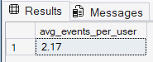

- --Most Active Users (Top customers by activity)
SELECT TOP 10
user_id,
COUNT(*) AS total_actions
FROM [e-commerce_data]
GROUP BY user_id
ORDER BY total_actions DESC;
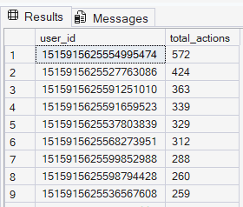

- --Most Purchased Users
SELECT TOP 10
user_id,
COUNT(*) AS total_purchases
FROM [e-commerce_data]
WHERE event_type='purchase'
GROUP BY user_id
ORDER BY total_purchases DESC;
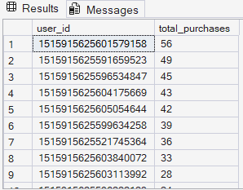

- --Monthly revenue
SELECT
FORMAT(CAST(REPLACE(event_time,' UTC','') AS DATETIME), 'yyyy-MM') AS month,
ROUND(SUM(price),2) AS revenue
FROM [e-commerce_data]
WHERE event_type = 'purchase'
GROUP BY FORMAT(CAST(REPLACE(event_time,' UTC','') AS DATETIME), 'yyyy-MM')
ORDER BY month;
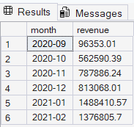

- --Monthly Purchases
SELECT
FORMAT(CAST(REPLACE(event_time,' UTC','') AS DATETIME), 'yyyy-MM') AS month,
COUNT(*) AS total_purchases
FROM [e-commerce_data]
WHERE event_type = 'purchase'
GROUP BY FORMAT(CAST(REPLACE(event_time,' UTC','') AS DATETIME), 'yyyy-MM')
ORDER BY month;
